Enrypted Chat Application Project
Error: Reference source not found

Version 1.0
Table of Contents

- INTRODUCTION 4
  - PURPOSE 4
  - SCOPE 4
  - DOCUMENT’S INTENDED AUDIENCE 4
  - OVERALL OVERVIEW 4
- SYSTEM OVERVIEW 5
  - MAJOR DESIGN ATIFACTS 5
  - FUNCTIONAL REQUIREMENT 5
  - SUPPORTING MATERIALS 6
  - DEFINITION AND ACRONYMS 8
- DESIGN CONSIDERATIONS 8
  - ASSUMPTION 8
  - CONSTRAINTS 8
  - SYSTEM ENVIRONMENT 9
  - DESIGN METHODOLOGY 9
  - ANTICIPATION DURING DEVELOPMENT 10
  - RISK AND FUTURE DESIGN CHANGES 10
- ARCHITECURAL DESIGN 11
- HIGH LEVEL DESIGN 16
- LOW LEVEL DESIGN 23
- USER INTERFACE 50
- SCENARIO 59
- LESSON LEARNED 66
Introduction

  - Purpose
The purpose of this project is to create a chatting program with encrypted messages for a safer chatting experience for the users.

  - Document’s Intended Audience
Lecturer’s Assistant, Robertus Hudi.

  - Overall Overview
This chat application is a one-client server and a two-way connectivity chat application. Server can only handle one client because the server also acts as a client. The server has the same function as client only that the client need to connect to the server to start chatting. The chat that is sent between the client and server are encrypted with Transposition Cipher. The way the cipher encryption and decryption works that makes the chat secure and private is by encrypting the text that is sent before it is sent through the network and decrypting the received encrypted message.

- SYSTEM OVERVIEW

- FUNCTIONAL REQUIREMENTS
  - User must input the IP Address and Port of the server to successfully run the program
  - The text sent by user is encrypted and decrypted on receive.
  - User can see the message sent after encryption and message received before decryption.

- DESIGN CONSIDERATIONS
  - ASSUMPTION
The assumption we use on the making of this project:
  - The program works flawlessly with close to no bugs.
  - All chat sent and received are guaranteed to be safe and kept encrypted on transmission.
  - Available to all devices running Windows.

  - CONSTRAINTS
The constraints faced while working on this project:
- Time: 2 weeks to complete the project.
- Other projects that needs to be finished.
- Budget of Rp. 20.000,-

  - SYSTEM ENVIRONMENT
The program was written in Java and is available for anybody in any environment that has Internet connection and suitable device to run the program.

  - DESIGN METHODOLOGY
The program use Transposition Cipher as the encryption and decryption method.

  - ANTICIPATION DURING DEVELOPMENT
Anticipation taken during the development of the application:
- The possible bugs that is going to occur are anticipated and subject to be fixed immediately.
- The encryption algorithm code will be difficult to make in a short amount of time.
- The project possible future changes are anticipated and will be discussed in the group for the changes.
  - RISK AND FUTURE DESIGN CHANGES
Changes that are taken to complement the risks:
- Application connectivity
The application can only have one client connected to it because it is only a one-way chatting program. Making a multi-client chat program with the encryption is not possible for us because of the short amount of time.
- Internet connection risk
The program requires internet connection and without internet connection, it can not function properly. The program can still works if the computers using the program are in the same network connection.

Our program can be made into a better chat program if we do:
- Multi-client chat server that still keeps the safety and privacy of chatting.
- Stronger server that can handle a lot of clients and also reside in an actual server and not a personal computer.
- Implementing a more complex encryption algorithm so that the encrypted messages cannot be easily deciphered by people trying to hack into the system.

- ARCHITECTURAL DESIGN
The server - client design is a two-way design which means that the client can send and receive messages form server and vice versa. This is the design because it is easier to implement the encryption and decryption algorithm into the code than a multi-client server design. The sending client takes the inputted text and convert it into ciphertext, then send the ciphertext and the receiving client receives the encrypted text and decrypt it.

Chat Client - Server Connection Design

Client

Server

- HIGH LEVEL DESIGN
The chat application uses client - server concept where the client connects to the server. Once the client connected to the server, both the server and the client can start chatting. This application is only a simple chat program and the server cannot handle more than one client. The text transmitted between client and server are encrypted for a secure chatting experience.

The encrypted chat application is built using:
- Programming language : Java. Java already have a library that is simple to use for networking. The reason java is used is also because it is the requirement of the project and the coders are more experienced using java language than any other languages.

- LOW LEVEL DESIGN
Server.java
import java.io.BufferedReader;
import java.io.InputStreamReader;
import java.io.PrintWriter;
import java.net.*;
import javax.swing.*;
import java.awt.*;
import java.awt.event.*;
import java.io.*;
public class Server extends JPanel implements Runnable, ActionListener, KeyListener {

private ServerSocket serversocket;
private BufferedReader br1, br2;
private PrintWriter pr1;
private Socket socket;
Thread t1;
private String sIn="", plainText="", cipherText="";
private JScrollPane jsp;
private JTextField text;
private String sText="", sChat="", sStatus="";
private JLabel status;
private JTextArea chat, cipherField;
private JButton send;
private boolean running;
boolean connect;
TranspositionCipher cipher = new TranspositionCipher();

public Server() {

try {
t1 = new Thread(this);
t1.start();

serversocket = new ServerSocket(5000);

} catch (Exception e) {
}

}

public void run() {
init();

while(running) {

update();

try {
int i = 0;
if( socket == null && i == 0) {
socket = serversocket.accept();
sStatus = "Connected with " + socket.getInetAddress().getHostAddress();
i++;
}
connect = socket.isConnected()&& !socket.isClosed();
//update();
pr1 = new PrintWriter(socket.getOutputStream(), true);
br2 = new BufferedReader(new InputStreamReader(socket.getInputStream()));
sIn = br2.readLine();
cipherText = sIn;
plainText = cipher.doDecryption(sIn);
cipherField.setText(cipherText);
sChat = sChat + "\n" + "Client : " + plainText;
}
catch(Exception e) {
}
}
}

public void update() {

chat.setText(sChat);
//cipherField.setText(cipherText);
status.setText(sStatus);
}

public void init() {
running = true;
setLayout(null);

Font f = new Font("Arial", Font.BOLD,16);

chat = new JTextArea(sChat);
chat.setBackground(Color.WHITE);
chat.setFont(f);
chat.setEditable(false);
chat.setLineWrap(true);
chat.setBounds(20, 65, 260, 290);
if(!connect) {
sStatus = "Waiting for connection . . .";
}

cipherField = new JTextArea(cipherText);
cipherField.setBackground(Color.WHITE);
cipherField.setFont(f);
cipherField.setEditable(false);
cipherField.setLineWrap(true);
cipherField.setBounds(300, 65, 260, 290);
add(cipherField);

status = new JLabel(sStatus);
status.setBackground(Color.WHITE);
status.setFont(f);
status.setBounds(20,10,600,50);
add(status);

jsp = new JScrollPane(chat);
jsp.setBounds(20,65,260,290);
add(jsp);

text = new JTextField();
text.setFont(f);
text.setBounds(20,370,500,40);
text.addKeyListener(this);
add(text);

text.requestFocus();

send = new JButton("SEND");
send.setBounds(535,370,85,40);
send.addActionListener(this);
add(send);
}

public void actionPerformed(ActionEvent e)
{
Object source = e.getSource();
if(connect) {
if(source == send)
{
sChat = sChat + "\n" + "Server : " + text.getText();
plainText = text.getText();
cipherText = cipher.doEncryption(text.getText());
sText = plainText;
pr1.println(cipherText);
chat.setText(sChat);
cipherField.setText(cipherText);
text.setText(null);
text.requestFocus();
}
}
}

public void keyTyped(KeyEvent key) {

}

public void keyPressed(KeyEvent key) {
int code = key.getKeyCode();
if(code == KeyEvent.VK_ENTER) {
send.doClick();
}
}

public void keyReleased(KeyEvent key) {}

}

Client.java

import java.io.BufferedReader;
import java.io.InputStreamReader;
import java.io.PrintWriter;
import java.net.*;
import javax.swing.*;
import java.awt.*;
import java.awt.event.*;
import java.io.*;
import java.util.Scanner;
public class Client extends JPanel implements Runnable, ActionListener, KeyListener {

private ServerSocket serversocket;
private BufferedReader br1, br2;
private PrintWriter pr1;
private Socket socket;
Thread t1;
private String sIn="",plainText="", cipherText="";
private JScrollPane jsp;
private JTextField text;
private String sText="", sChat="", sStatus="";
private JLabel status;
private JTextArea chat, cipherField;
private JButton send;
private boolean running;
boolean connect;
TranspositionCipher cipher = new TranspositionCipher();

public Client() {

String IPAddress;
int Port;
Scanner input = new Scanner(System.in);
System.out.print("Enter IP Address: ");
IPAddress = input.next();
System.out.print("Enter Port: ");
Port = input.nextInt();

try {
t1 = new Thread(this);

t1.start();
socket = new Socket(IPAddress, Port);
connect = socket.isConnected() && !socket.isClosed();

} catch (Exception e) {
}

}

public void run() {
init();

while(running) {

update();
try {
//update();
pr1 = new PrintWriter(socket.getOutputStream(), true);
br2 = new BufferedReader(new InputStreamReader(socket.getInputStream()));
sIn = br2.readLine();
cipherText = sIn;
plainText = cipher.doDecryption(sIn);
cipherField.setText(cipherText);
sChat = sChat + "\n" + "Server : " + plainText;
}
catch(Exception e) {
}
}
}

public void update() {

chat.setText(sChat);
//cipherField.setText(cipherText);
status.setText(sStatus);
}

public void init() {
running = true;
setLayout(null);

Font f = new Font("Arial", Font.BOLD,20);

chat = new JTextArea(sChat);
chat.setBackground(Color.WHITE);
chat.setFont(f);
chat.setEditable(false);
chat.setLineWrap(true);
chat.setBounds(20, 65, 260, 290);
if(!connect) {
sStatus = "Connected to Server";
} else
{
sStatus = "Connected with " + socket.getInetAddress().getHostAddress();
}

cipherField = new JTextArea(cipherText);
cipherField.setBackground(Color.WHITE);
cipherField.setFont(f);
cipherField.setEditable(false);
cipherField.setLineWrap(true);
cipherField.setBounds(300, 65, 260, 290);
add(cipherField);

status = new JLabel(sStatus);
status.setBackground(Color.WHITE);
status.setFont(f);
status.setBounds(20,10,600,50);
add(status);

jsp = new JScrollPane(chat);
jsp.setBounds(20,65,260,290);
add(jsp);

text = new JTextField();
text.setFont(f);
text.setBounds(20,370,500,40);
text.addKeyListener(this);
add(text);

text.requestFocus();

send = new JButton("SEND");
send.setBounds(535,370,85,40);
send.addActionListener(this);
add(send);
}

public void actionPerformed(ActionEvent e)
{
Object source = e.getSource();
if(connect) {
if(source == send)
{
sChat = sChat + "\n" + "Client : " + text.getText();
plainText = text.getText();
cipherText = cipher.doEncryption(text.getText());
sText = plainText;
pr1.println(cipherText);
chat.setText(sChat);
cipherField.setText(cipherText);
text.setText(null);
text.requestFocus();

}
}
}

public void keyTyped(KeyEvent key) {

}

public void keyPressed(KeyEvent key) {
int code = key.getKeyCode();
if(code == KeyEvent.VK_ENTER) {
send.doClick();
}
}

public void keyReleased(KeyEvent key) {}

}

- USER INTERFACE
Server
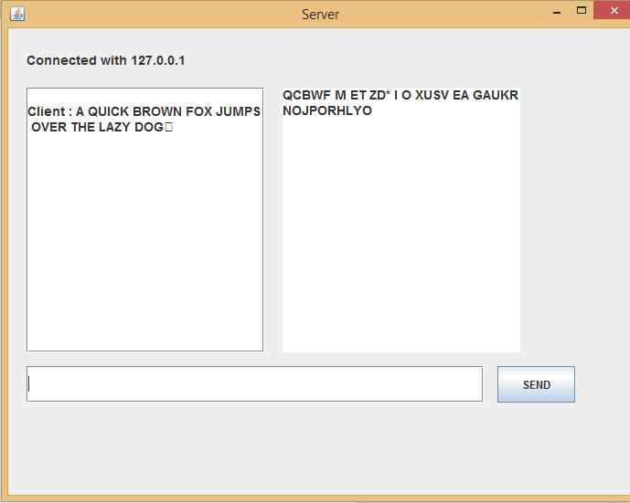

Client
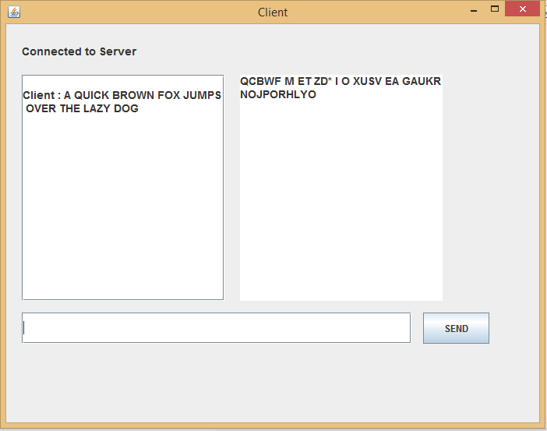
8. SCENARIOS
Actor:
User
Role:
Client
Assumption and dependencies:
There are only 2 users who are using this application. They must know the IP address as well as the port. More importantly, they need to have internet connection.

The user can :
- Send Message
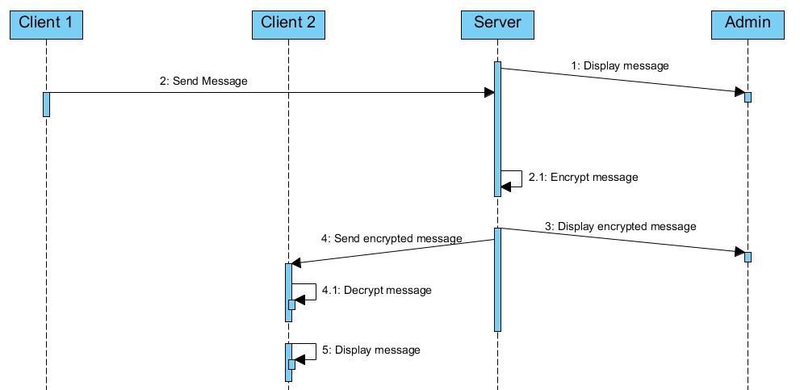

- Matching IP Address
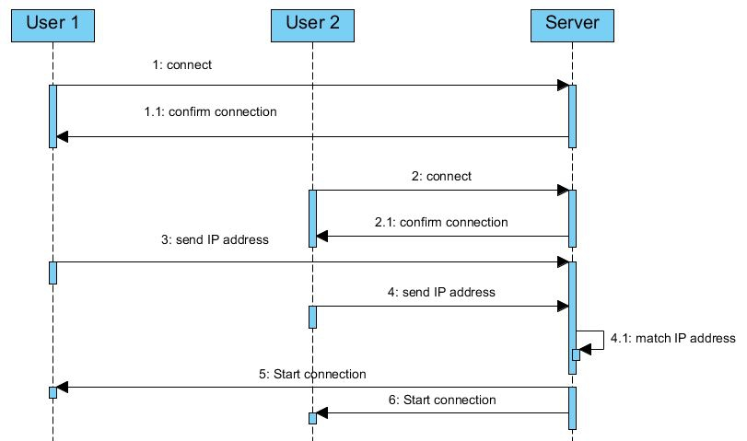

9. LESSON LEARNED
We have learned that creating a high security chat application is not easy and may take some time. Implementing encryption in a chat program is a challenging task. Overall we have improved in understanding how to create encryption and decryption messages.

